**ASSIGNMENT 7.4**

**Write a word count program using partitioner and implement the following logic in the partitioner words with length 5 should go into reducer 1 and words with length 6 should go into reducer 2 and the rest of the words should go into reducer 3.**

**DRIVER CLASS:**

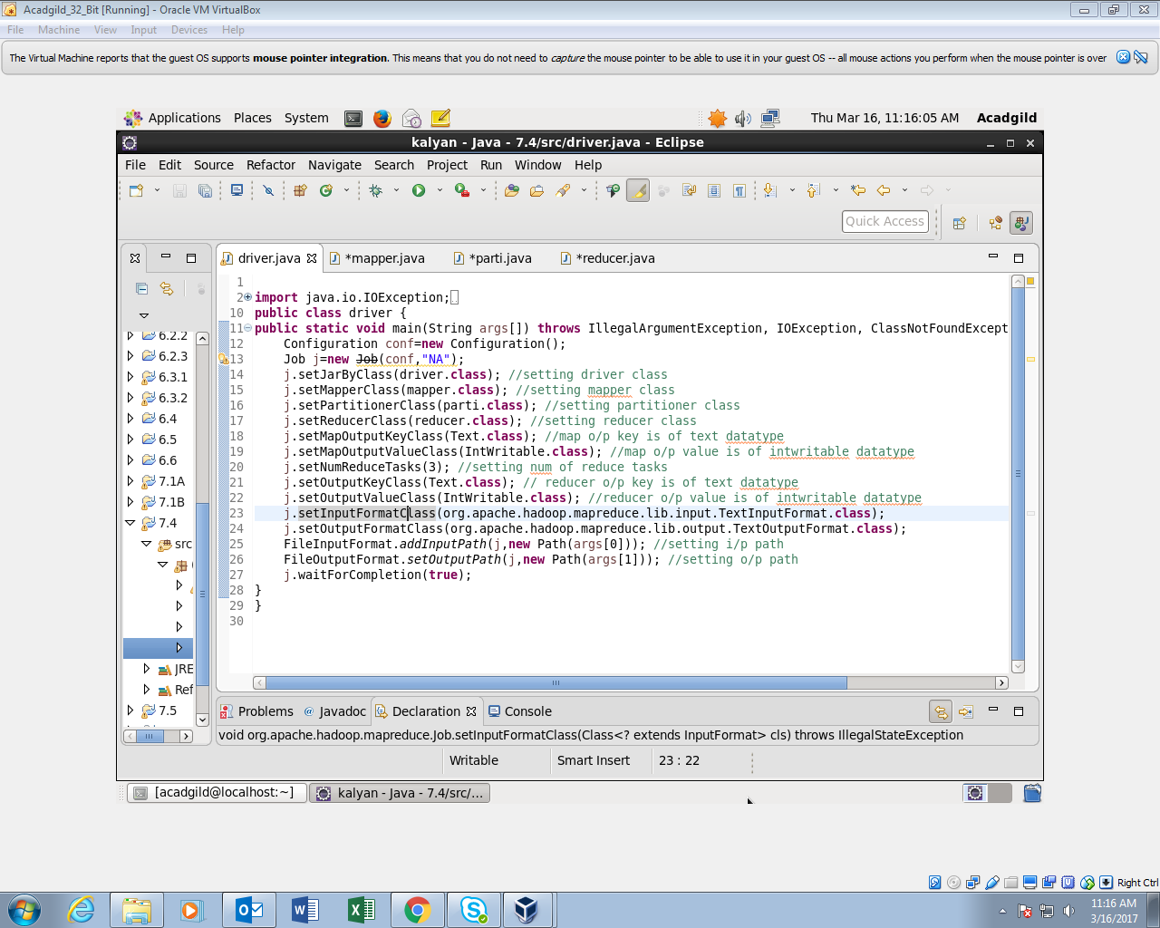

**MAPPER CLASS:**

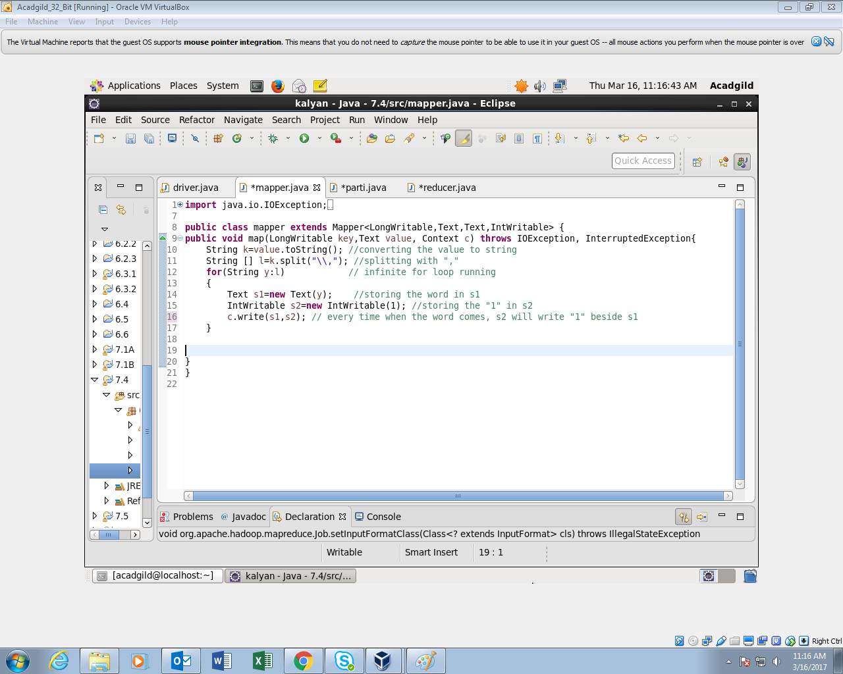

o/p of the Mapper will be like this Aravind 1,1,1,1.

This o/p goes as the i/p for partitioner class where the words get partitioned as per the length.

**PARTITIONER CLASS:**

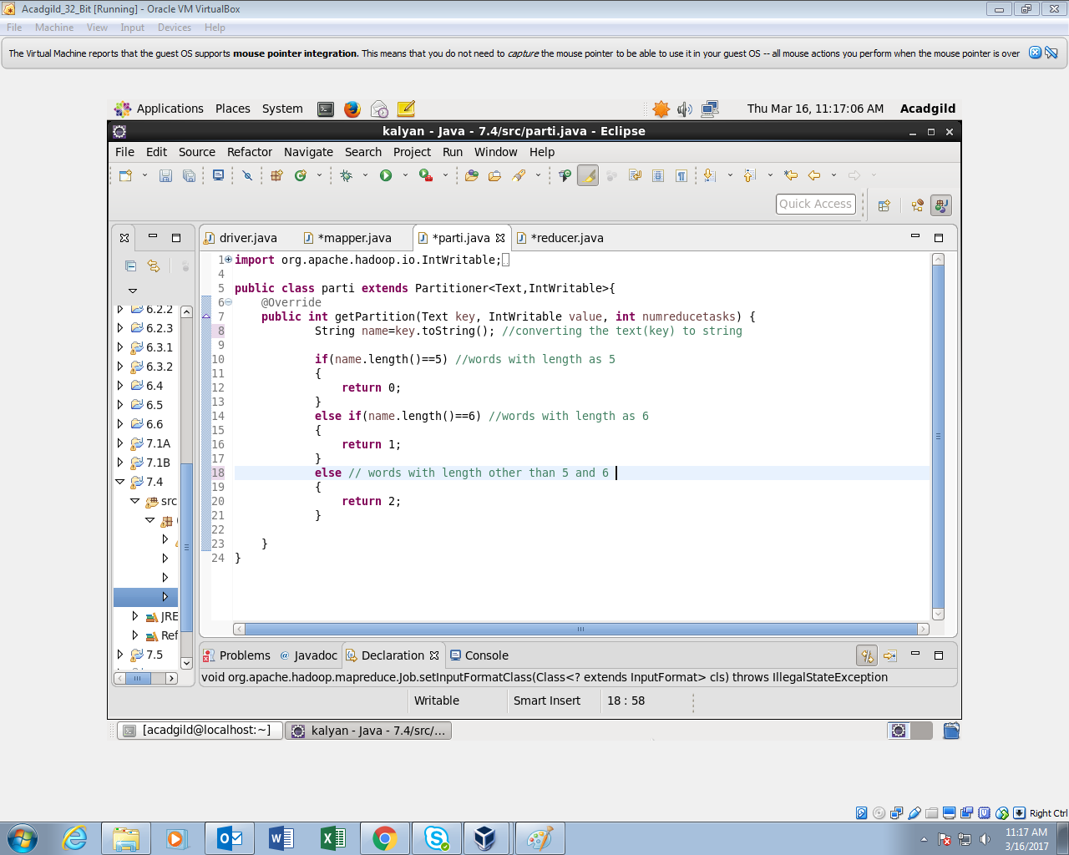

Words of length 5 will go to the reducer 1

Words of length 6 will go to the reducer 2

Words of length other than 5 and 6 will go to the reducer 3.

**REDUCER CLASS:**

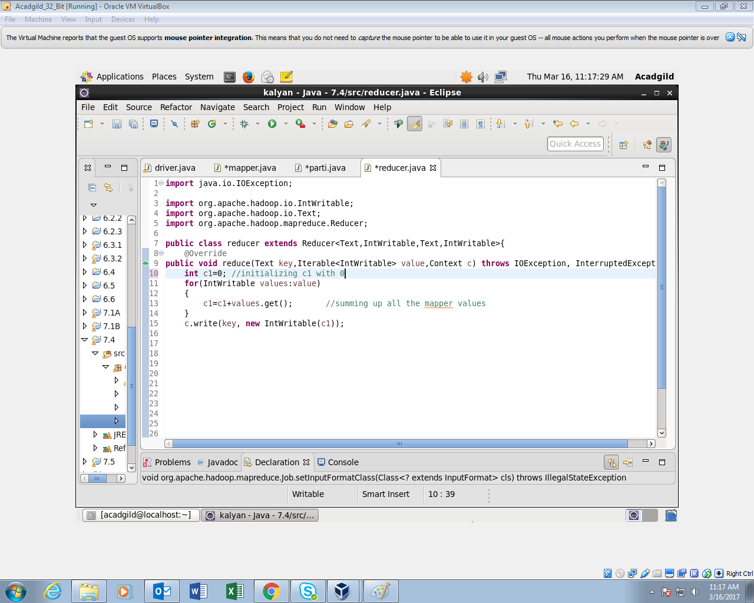

Thus it produces 3 o/p files.

First file consists of words of length 5 and their count

Second file consists of words of length 6 and their count

third file consists of words whose length is other than 5 and 6 and their length